**Unity Production Log**

**Table of** **Contents**

Introduction 1

Gameplay Mechanics 1

Gameplay loop 1

Tools and Features 1

Programming Fundamentals 2

Collidable Script 2

Player 3

Player Shooting 4

Random Room Generation 6

Room Movement 7

Camera Movement 8

Chests and Coins 8

Items and Inventory 10

## Introduction

This is the production log for my unity project for the making of different aspects in my game, currently parts that make the game unique are not yet included and only important features have been included.

## Gameplay Mechanics

Here’s a list of the mechanics I will (eventually) add:

* Top-down shooting combat,
* Semi-randomly generated maps,
* Items that boost the player’s abilities,
* An emphasis on ASCII symbols,
* Purchasable paths to fill gaps in the map,
* Semi-randomly generated worlds,
* UI including health, items, and minimap,
* Perma-death.

## Gameplay loop

Player starts the game with nothing, they can defeat enemies and collect loot to make themselves stronger, after they beat the boss of the floor they can proceed to the next randomly generated floor with new harder enemies and new items. This repeats until the player beats a certain number of floors or dies during the run, in which they will be sent back to the beginning with no items.

## Tools and Features

Unity has many tools to help with the development of a game, most of which can be obscure and not necessary to make the game.

## Programming Fundamentals

There are many parts to the programming side of the unity project which allows for various types of game to be made, a lot of the processes are extremely specific at what they do, but some are more commonplace in code.

* **Variables** – Holds and stores a piece of information given to them.
* **Arrays** – Holds multiple pieces of information inside of a list.
* **If Statements** – Checks if a statement is true and then runs instructions given to it.
* **Loops** – Code can be looped to occur multiple times, the most common two are For and While loops.
* **Functions** – Used to store large sections of code that may be reused, can then be called later and given parameters.
* **Classes** – Used in object-oriented programming to hold all the information that determines the behavior of the code and object.

## Collidable Script

This script will be used to detect when colliders overlap with the script owner’s collider, this class will be inherited by most other scripts so that they can also use it to easily detect.

## Player

This script will be used by the player object to move with WASD and detect items that the player collects.

## Player Shooting

This will also be used alongside the other player script to shoot a moving object, this first script handles the inputs, and instantiation of the rotated player bullet, this will only allow the player to shoot in one of 8 directions every second or so.

This Bullet Script script will be assigned to the bullet object in order to make it transform/move in the scene, the direction of movement is based on the rotation of the bullet set by the player Shooting script, it also detects when it collides with another object which will then remove it from the scene.

This will delete the owner of the script (likely assigned to the bullet object) after the designated amount of time has passed

## Random Room Generation

This RoomTemplates script stores all the variations of rooms including the base rooms and the obstacles that will be placed inside said rooms, after some amount of time it will spawn the obstacles and a boss room.

This script adds the current room to the RoomTemplates rooms list on the first frame it is created.

This is the Spawnpoint script which is given to the Spawnpoint game objects that appear on every side that has a door, it controls the random instantiation of rooms and prevents rooms from spawning on top of each other by spawning a blank room

## Room Movement

This script is used to teleport (transform) only the player object to the adjacent room.

## Camera Movement

The camera moves to the room which the player is inside of and is static while moving inside a single room.

This Script is given to the rooms to transform the camera, they take the current position and move the camera incrementally towards the new target location.

## Chests and Coins

This script is purely used to store the values of things the player has in a small script.

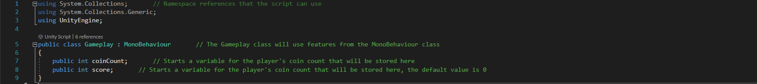

This Collectable script is like the collidable script but will focus on stopping objects from being collected multiple times.

This Chests script is given to chests to spit out a set amount of coins when the player touches the chest.

The Coin script is give to all Coin objects, it will add itself to the total coin count before then deleting itself

This is like the bullet script, but slows down the coin projectile after some time.

## Items and Inventory

This script creates a new inspector screen specifically for items.

This script makes a new create option that automatically adds these parameters when used.

This script is given to all item objects to set and determine what they are.

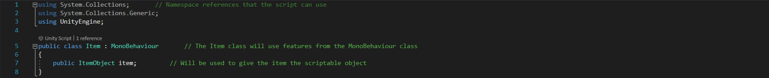

This script adds new items to the inventory when they are picked up.

This will update the inventory every item that is collected, and also when starting the scene.

A script used to instantiate a random item game object.

